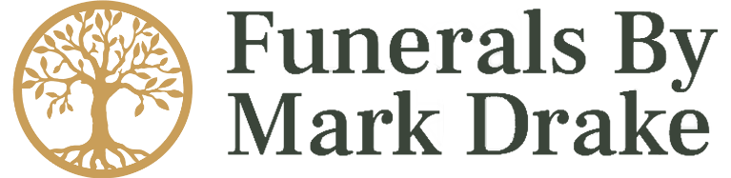

Additional Options Price List

Transfer from a private address/nursing home in Lowestoft, Beccles or Gorleston area £250.00
Transfer from a private address or nursing home as above (out of hours) £325.00
Transfer from James Paget or Norfolk & Norwich University Hospitals £250.00
Transfer from other locations (based on mileage beyond 40 miles £250) Plus £1.50 per mile
Transfer of deceased outside of normal working hours £250.00
Conducting the funeral service outside of normal working hours £200.00
Viewing in our chapel of rest (out of hours) from £50.00
Daily charge for extended care beyond 30 days, due to family request per day £25.00

Provision of a Limousine and Driver £200.00
Electric Hearsette £175.00
Electric Family Car £75.00
Additional Bearers required beyond 4 (Price per bearer) £45.00
Attendance of Funeral Director at Interment of Ashes £95.00
Additional charge for delivering ashes beyond a 20 mile radius of branch £1.00 per mile
Temporary Grave Marker £35.00

Grave Preparation Fee price on request
Horse Drawn Hearse price on request
Printed Orders of Service price on request
Additional time & charge for vehicles price on request
Webcasting Service price on request
Floral Tributes price on request
Masonry Services price on request

Coffins & Urns

Oak effect foil coffin (standard coffin) £295.00
Mahogany effect foil coffin £335.00
Oak veneer coffin (premium coffin) £495.00
Jute Hessian coffin £295.00
Willow coffin from £495.00
Picture coffin from £595.00
Glitter coffin from £695.00
Heritage collection coffin from £595.00
Marble effect coffin from £725.00
Blackboard coffin & pens £450.00
Solid coffins & caskets Price on request

Wooden ashes casket (single) from £59.00
Wooden ashes casket (double) from £89.00
Scatter tube from £15.00
Large urns from £95.00
Large tear urns from £195.00
Small keepsake urns from £40.00
Miniature keepsake urns from £25.00

